Introduction: Reading a science textbook is very different from reading a novel. I will explain five different methods to help you read your biology textbook. They all have one thing in common. They all encourage you to read with a purpose. You will learn to quickly select the important ideas and facts, understand what they mean, make them easy to review, and increase your retention of information.

1. SQ3R
Survey
The initial survey or preview of the material is the most important element in the SQ3R method of study. This gives you a preview of the material you are about to learn about. Read and think about the clues in the text. Look at the Chapter title, the section title, the section headings, bold-faced words, pictures and captions, tables and charts, end of section questions, main ideas, and vocabulary, After doing so you should be able to answer these questions: What is this section about? What are the key concepts that I should know after reading this section? Surveying the section should take you about 2-4 minutes.

Question
Now it’s time to write something down in your learning log. This is when you anticipate what information is important enough for your teacher to ask you on our next quiz. Remember that this biology textbook is not a romance novel. The author of your book spent a lot of time and effort to compile the important concepts that are critical for you understanding of biology into a very user-friendly format. This textbook is a great resource. Based on your survey of the section anticipate what information is important and write down questions in your learning log. Use the words who, what, where, when, and how in your questions. When you become good at this you will find that you will accurately anticipate all of the questions that are on our quizzes in biology.

Read
You already have questions written down in your learning log. Now its time to read, but you only read to find the answer to the questions you wrote down. This is not a novel! You’ll be asleep in minutes if you try to read this book from cover to cover. Only read to answer the questions you made.

Recite
Now it’s time to write more in your learning log. In your own words write down answers to the questions you made. Do not write down answers word for word out of the textbook. This means that you have no idea of what you just read. Remember, use your own words to answer your questions. This means that you understand what you read. If you find something you think you should add, by all means do it! This is your blank canvas to write. Draw anything that will help you remember and learn the material. Skip lines or leave room in the margin so you can add more information during class or when your understanding becomes clearer.

Review
You will make notes in your learning log virtually every day. If I ask you to summarize pages out of your book, it is because your author has done a good job of summing up information about an important concept in biology. I don’t expect you to memorize all of this new vocabulary and concepts, but I do expect you to look at what you have written and use it to answer questions. You should constantly be adding to what you have written as your understanding of concepts become clearer. If you haven’t figured it out, I let you use what you have written in your learning log on our quizzes.

2. Outline
Your biology textbook is already set up in an outline format. Each section begins with a connect concepts idea to help you draw the new information that you are about to learn to a concept you already know. Then each section is separated into a series of main ideas. In your learning log write down the main concept. Then list the important sub-concepts. Make sure to use cues in the text so you don’t miss the critical ideas. Use boldfaced words, pictures and captions, and section questions.
Example:
- Atoms, Ions, and Molecules
- Living things consist of atoms of different elements
An atom is……
An element is…..
A compound is……
Bohr’s atomic model
- Ions form when atoms gain or lose electrons
An ion is….
An ionic bond is…..
Picture of ionic bond…
A key downfall to the outline form of note taking is when you don’t put concepts into your own words. You should also leave room to expand on your notes as your understanding becomes deeper.

3. QAD
Split your page in your learning log into three columns. Label them question, answer, and drawing
Question
Using cues in the textbook such as main ideas, section headings, vocabulary, bold-faced words, figures and captions, and end of section assessment questions, write questions in the question column of your learning log. Again, when you get good at this you will accurately anticipate the questions that will be on the quiz over this section.

Answer
Read the text only to answer the questions you made. Then in the answer column write answers to the questions you made in your own words. Leave room to expand on your answer during class or when your understanding of the concepts becomes deeper.

Drawing
In the third column of your learning log give your best drawing of the concept or idea you made your question and answer about. Studies show that drawing ensures a greater understanding of concepts than just using written vocabulary.
4. KWL
Split your page in your learning log into three columns. Label them K-W-L. Survey the text for main ideas, bold-faced words, and section headings. Don’t forget that important concepts may be found in the captions and pictures.
Know
In this column write down what you already know about the main ideas, bold faced words, and section headings. It is important to utilize background knowledge to enhance new learning about these concepts.

Want to know or Will learn
In the middle column either list what you want to know about these concepts, or more importantly list what you think you will learn about the concepts and ideas covered in the section of the textbook.

Learned
In the last column in your learning log write what you have learned after reading the textbook section. Make sure it is in your own words. Also leave room to add to your homework in class. Unless it is a topic that you already have a lot of background knowledge on the learned column might take up half your page.

5. Graphic Organizers

A graphic organizer is a great way to summarize key biological concepts from your book. The best thing about graphic organizers is they allow you to link concepts together. This visual organization allows you to use more areas of your brain and gain a greater understanding of concepts. Here are seven different examples of concepts maps you can use. Eventually the best concepts maps will be ones that you design.

Examples:
Scientists Biography
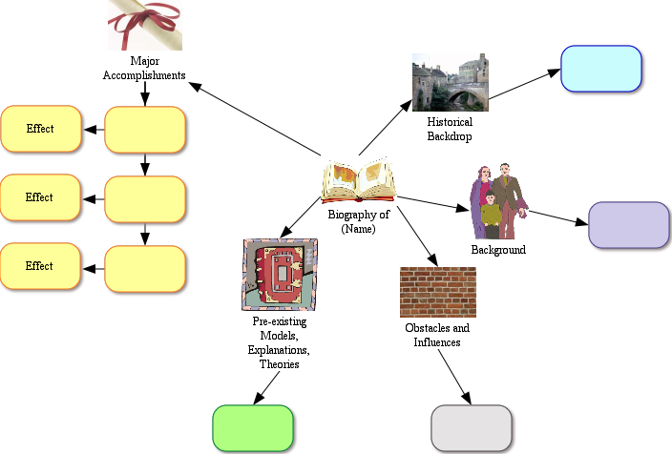

Classification
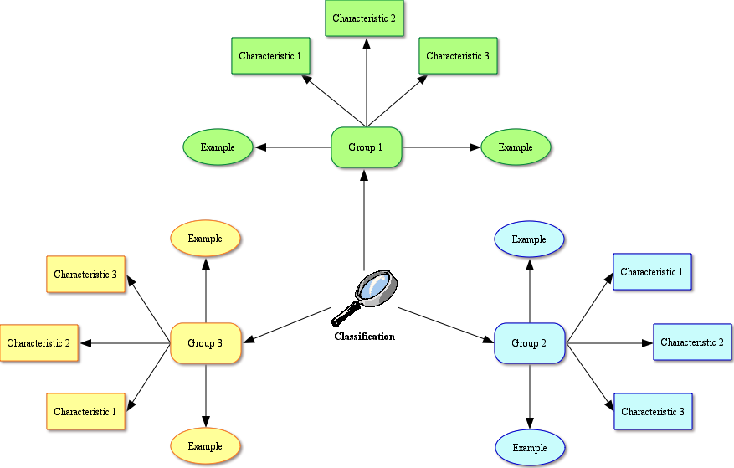

Concept Map
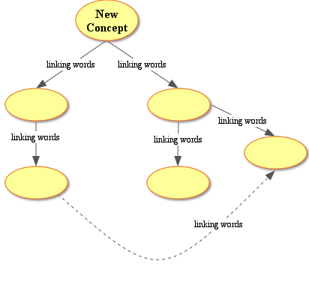

Experimental Design
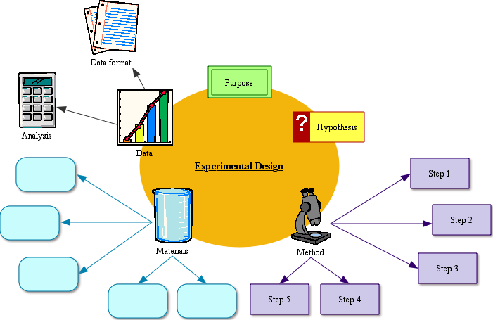

Levels of Organization
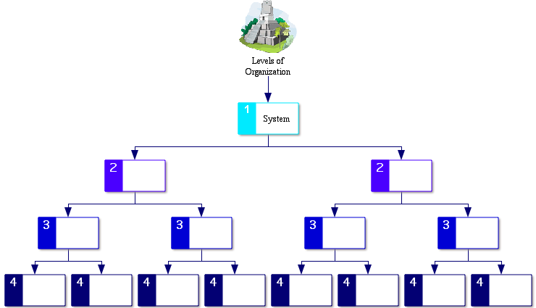

Simple Cycles
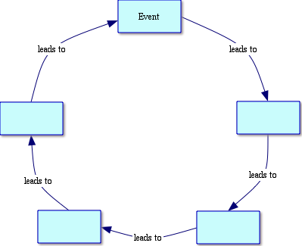

Structure and Function

